Database Name: **Northwind**

1. Display the product names along with their supplier name

select p.productname,s.companyname

from [Northwind].[Products] p left join [Northwind].[Suppliers] s

on p.supplierid = s.supplierid

1. Display the product names and the category which the products fall under. Also display the supplier’s name

select p.ProductName, c.[CategoryName] from

[Northwind].[Products] p inner join

[Northwind].[Categories] c on p.categoryid=c.categoryid

inner join

[Northwind].[Suppliers] s on s.supplierid=p.supplierid

1. Display the Order_id, Contact name and the number of products purchased by the customer

select o.orderid,c.contactname,count(*)products_count

from [Northwind].[Orders] o join

[Northwind].[Customers] c on

o.customerid=c.customerid join

[Northwind].[Order_Details] od on od.orderid=o.orderid

inner join

[Northwind].[Products] p on od.productId=p.productid

group by c.contactname,o.orderid

1. Display the Order_Id, Contact name and the shipping company name having Brazil as the ship country

select o.orderid,c.contactname,s.companyname

from [Northwind].[Orders] o join

[Northwind].[Customers] c on

o.customerid=c.customerid join [Northwind].[Shippers] s

on s.shipperid=o.shipvia

where o.shipcountry='brazil'

1. Display the Order_Id, contact name along with the employee’s name who handled that sale. Also display the total amount of that particular order

1. Display the product names that were sold by the sales manager

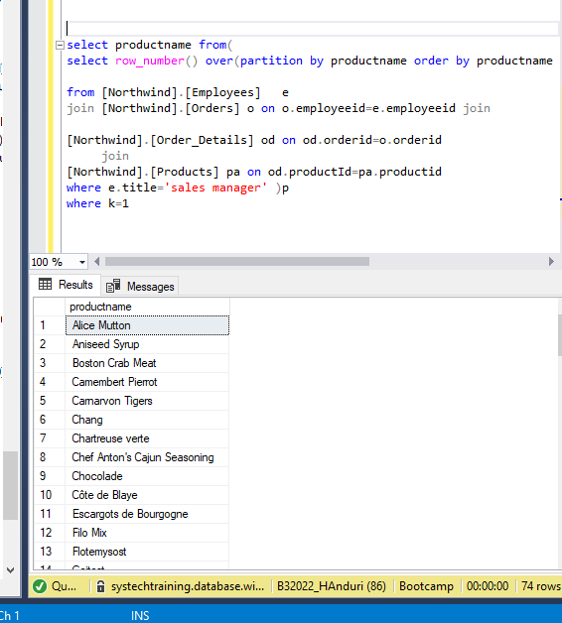

1. Fetch all the columns from suppliers with the corresponding product id and product name. If the Region is Null concatenate the first letters of country and city, should be in Upper case.

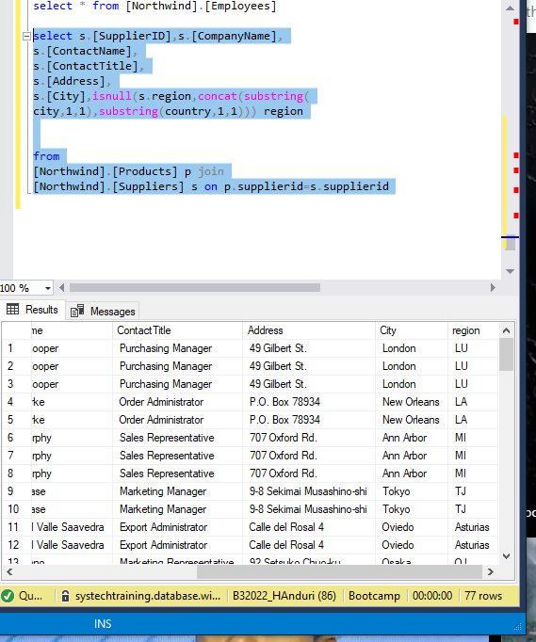

1. Display the company name, contact name, city along with the Unit price from products. Fetch all the records from suppliers. Handle the null values

select s.[CompanyName],

s.[ContactName],p.unitprice,

s.[City]

from

[Northwind].[Products] p join

[Northwind].[Suppliers] s on p.supplierid=s.supplierid

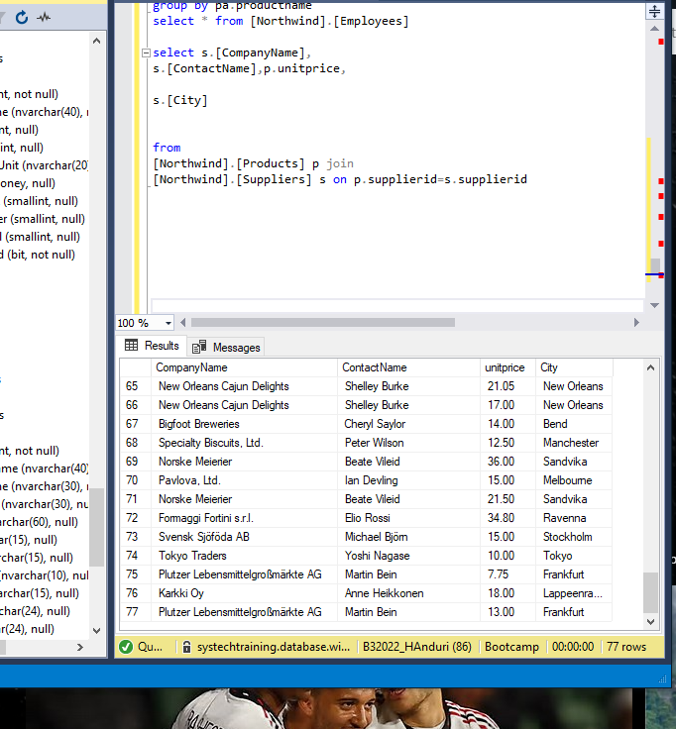

1. Select customer id, ship name, ship city, territory description, unit price and discount wherein the territory id should not exceed four characters and the ship via should be 1 or 2. If the discount is 0, then replace it with 6% unit price.

select

c.customerid,o.shipname,o.shipcity,

case when od.[Discount]=0 then od.unitprice*(106/100)

else od.unitprice

end as unitprice

from

[Northwind].[Customers] c join

[Northwind].[Orders] o on

c.customerid=o.customerid

join

[Northwind].[Order_Details] od on od.orderid=o.orderid

where o.shipvia in(1,2)

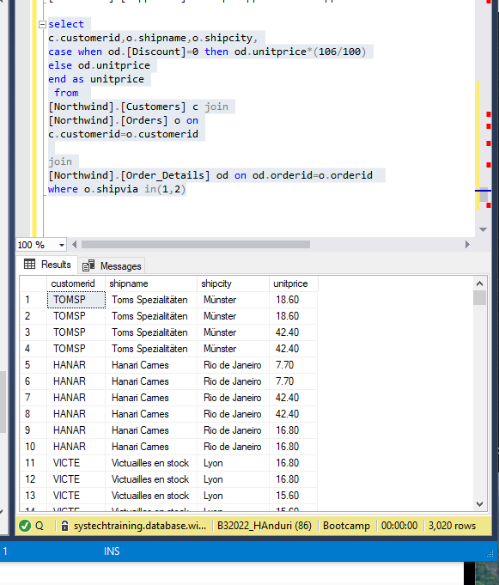

1. Display the order id, customer id, Unit price, quantity where the discount should be greater than zero.

select

o.orderid,o.customerid,od.unitprice,od.quantity

from

[Northwind].[Orders] o

join

[Northwind].[Order_Details] od on od.orderid=o.orderid

where od.discount>0

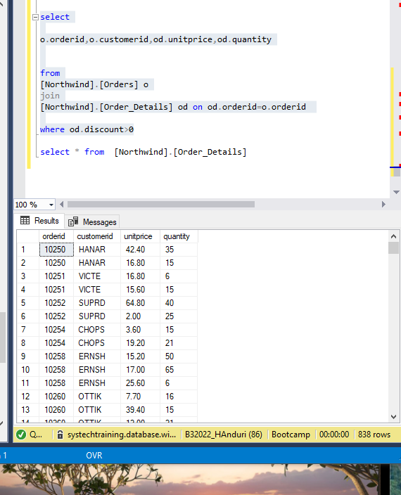

1. Select the category id, category name, description, product name, and supplier id and unit price. Where the description should not exceed two subcategories.

select

c.[CategoryID],c.[CategoryName],c.[Description],p.[SupplierID],p.

[UnitPrice]

from

[Northwind].[Categories] c join

[Northwind].[Products] p on c.[CategoryID]=p.[CategoryID]

where

len(cast(c.

description as varchar))-len(replace(cast(c.

description as varchar),',',''))=0

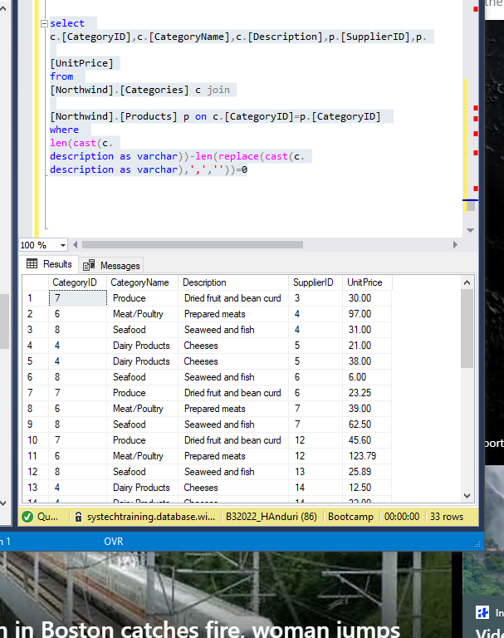

1. Write a query to select only the first letter in each word present in the column 'Contact Name'. (E.g.: A Beautiful Mind-ABM) and name this column as 'Short Name'. Do order by 'Short Form'.(use Suppliers table )

select

(

select

string_agg(left(

value,1),'')

from string_split(

ContactName,space(1)))as 'short name'

from

[Northwind].[Suppliers]

